**Containerize The App**

|  |  |
| --- | --- |
| **Date** | 09 November 2022 |
| **Team ID** | PNT2022TMID37413 |
| **Project Name** | Project-Smart Fashion Recommender  Application |

# DOCKER

**PUSH:**

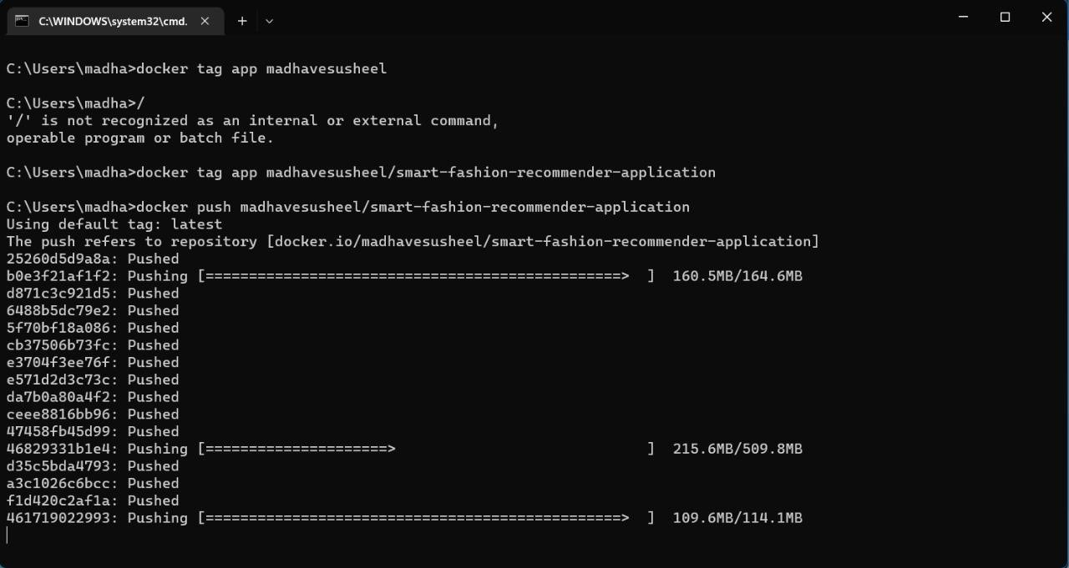

**CONTAINERIZING THE APPLICATION:**

